Title in Progress

***Photoshop poster with game name, team name & team members and team logo***

***\*Add weapon details. Baby – Ball, Teen – Slingshot and Adult – Brawler\****

***\*\*Add the rest of the mechanics down** Done***

***\*\*\*Start level design*** Done***

***\*\*\*\*Start a storyboard\*\*\*\****

***\*\*\*\*\*influences\*\*\*\*\****

***\*\*\*\*\*Sketches of the artwork***** Done***

***Let David Know what’s been changed***

***\*Menu system* doc***

***\*\*Mechanics** doc***

***\*\*\*Level Design*** - in book***

***\*\*\*\*Weapon Details**** in book***

***\*\*\*\*\*Sound Design***** in book***

Table of Contents

**Overview** 4

**Game Design** 4

Level Design 4

Level 1 4

Level 2 4

Level 3 4

Objectives 4

Art work 4

Animation 5

Sound Design 5

**Mechanics** 5

Time Travel 5

Jump 5

Crawl 5

Running 5

Combat 5

**User Interface** 6

Menu System 6

Main title screen 6

Start Screen 7

Option Screen 7

About Screen 8

Controls 8

Keyboard and mouse 8

Left handed Keyboard controls 8

**Xbox Controller** 8

User experience 8

Wireframes 8

**Marketing** 8

Who the marketing aimed at 8

Posters 8

Video edit 8

**Pseudocode** 8

**Flowchart** 8

**References** 8

# **Overview**

Target Audience

Why we chose the idea

# **Game Design**

Rules

Modes

Characters

Main

Enemy

Objects

Story

Aim

Why

The end

## Level Design

## Level 1

## Level 2

## Level 3

## Objectives

Main

Side

## Art work

Characters

Weapons

Enemy

Objects

## Animation

Start sketches

Progression sketches

Final production

## Sound Design

Voices

SFX

# **Mechanics**

## Time Travel

The time travel is the standout feature that makes the game unique from other games with the ability to reverse in time to a baby to fast forwarding yourself into the a man to get access to different areas of the level depending on the type of character you are; you can gain access to this mechanic by pressing the number keys 1,2 and 3 – by pressing the number one you’ll become the baby, by pressing number 2 you will become the teenager and if you press number 3 you become the adult – on console on the controllers you press the D pad left to become the baby, up to become the teenager and right to become the adult.

## Jump

The jumping mechanic can only be used by the teenager and the adult as the baby can only crawl. The teenager can jump higher than the adult as he is much younger and is in more shape than the adult, the reason behind the obstacle is that the teenager can reach higher places that the adult cannot – you press space on the keyboard to perform this mechanic and to perform it on controller you will press the A button.

## Crawl

Crawling is a feature only the baby can do as it gives the baby a unique mechanic to be able to get to places the teenager and the adult cannot giving the baby a specific use in the game. This mechanic is planning to be implemented by putting the baby in vents to be able to get places to help achieve the goal that is required to in the level – the baby crawls by pressing L-Shift (*Left Shift*).

## Running

Only the adult and the teenager are able to run but in different styles and speeds for different obstacles that are in the way you may not need to change to the teenager from adult if the obstacle is lower down. The lower the obstacle the less likely you will be needed to use the teenager. This mechanic has been implemented in the game as it is a common game design practice but to also make the player think they have to use a rewind/fast forward to complete the task that’s given to them – this can be achieved by pressing L-Shift (*Left shift*) with the teenager and the adult and accessible on controller by pressing left bumper.

## Combat

All characters are able to engage in combat in different strengths and capabilities we mainly made the adult stronger to give him his mechanical purpose and to give him a special ability like the baby with crawling and the teenager with the athleticism – the combat system can be accessible on keyboard with the left mouse click and on controller the right bumper.

#### Baby

The baby delivers the least amount of damage to the enemy as a baby hasn’t fully developed so it’s throwing power is near none existent.

#### Teenager

The teenager manages to cause more damage than the baby but will also take a few hits to manage to defeat the enemies.

#### Adult

This is the special ability of the adult and can deal significant damage to any enemy as he has throwing power unimaginable to the other two and can easily take out the enemy that’s in front of him similar to anime series “***one-punch man***”

# **User Interface**

## Menu System

When developing a menu system you want to make it very streamlined while making it as thorough as possible.

As a team we set out deciding what would make a good menu system. We decided that the menu should consist of a title screen to give the player a introduction of the game, a start screen to let the player start from the second screen but also has a option and about section for players that like to adjust things in the game to suit their play style and for players that enjoy the game to the point that they are intrigued to find out who created the game and what were the reasons behind some of the design choices.

The animation & artist – ***Brendan McNally*** thought it would be a good idea for the menu to introduce all three characters baby, teen and adult. The baby would be the introductory character then depending if the player selects option or about they’ll be introduced to the teenager and the adult.

### Main title screen

The main title screen is the introduction to the game with the logo of the game with the simple options of Start and Exit. This design choice was taken place as it makes everything very basic and simple for every player to understand.

### Start Screen

Once you have selected start from the main title screen you are then taken to the start screen which introduces the baby character with the buttons start, options, about and back to select:

#### Start

The start button takes you to the game which will begin from where the player last left off from. If it is the first time the game is being started then you then begin the game from the very beginning.

#### Options

The option screen takes you to the option menu which lets you control the sound and difficulty and starts a menu animation.

#### About

When you click on the about section you are introduced to the adult character in the menu animation transition with the options to find out about the developers more and to find out about the game more like a behind the scenes of the game and some of the design choices and why they where made.

#### Back

Back will take the player to the title screen which lets them either look at the logo of the game or exit of the game.

### Option Screen

When you select the option screen it will trigger a fast forward animation showing the baby turn into a teenager this is due to the developers wanting the player to wonder what is happening with the baby turning into a teenager and what that has to do with the game.

You will be greeted with a sound, difficulty and a back button – Sound: letting the sounds be adjusted, difficulty: letting the player control how difficult the game is, Back: taking player to the previous screen.

#### Sound

This sub menu will take you to the sound menu which will give you three slide bars to determine the level of volume coming from the game firstly you have the control of the music volume of the game, secondly you have the sound effects of the game (SFX) which will be the sound of the character walking, running, shooting and ambient sounds of the game and lastly you have control to determine the sound of the dialog being played if the voices are too loud in-game.

#### Difficulty

The difficulty sub menu will let the player decide how difficulty they want the game to be as we plan to make it as challenging as possible but not making it so hard that you cannot physically complete the levels. This will be handy for the casual players that just want to experience what the game has to offer but also for the perfectionist that wants to challenge themselves to complete the game in it’s most difficult state.

#### Back

This is a simple back button which will trigger to get the game to go back to the start screen; it will play an animation which makes it look like it’s rewinding back to the start screen as the teen rewinds into a baby.

### About Screen

#### Developers

In the develops page you are introduced to the developers that created the game when you press the developer it shows their name, age, occupation in the project and any links for them to be contacted. We thought this was a good idea because if a player really enjoys the game that is in the game industry that they can be contacted.

#### Developers Thoughts

In the developers thoughts you are introduced to the behind the scenes of the game such as the direction of the art, the direction of the project in general giving players invested in the game an idea onto how the game is created.

## Controls

### Keyboard and mouse

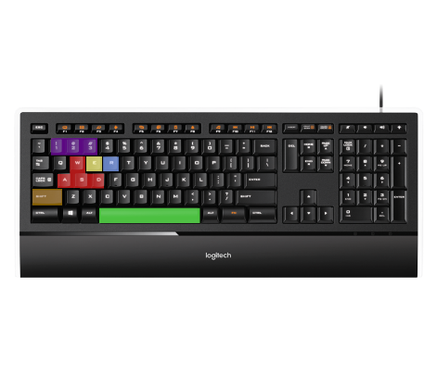

W,A,S,D – Movement Controls (W: Up, A: Left Strafe, D: Right Strafe and S: Backwards

E - Interaction

R - Reload

L-Shift – Sprint & Crawl (Baby)

Space – Jump

1,2,3 – Switch Characters.

Left Click – Shoot

### Left handed Keyboard controls

### **Xbox Controller**

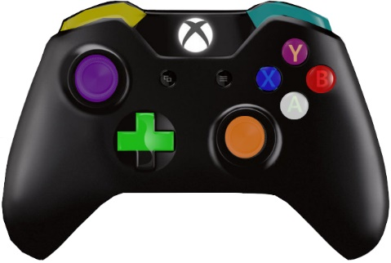

Left Analog – Movement

D-Pad – Changing between Baby, Teen and Adult

Right Analog – Camera Movement

Left trigger – Sprint / Crawl faster (Baby)

Right trigger – Shoot

A – Jump

B – Crouch

X – Reload

Y – Interact

## User experience

## Wireframes

# **Marketing**

## Who the marketing aimed at

## Posters

## Video edit

# **Pseudocode**

# **Flowchart**

# **References**